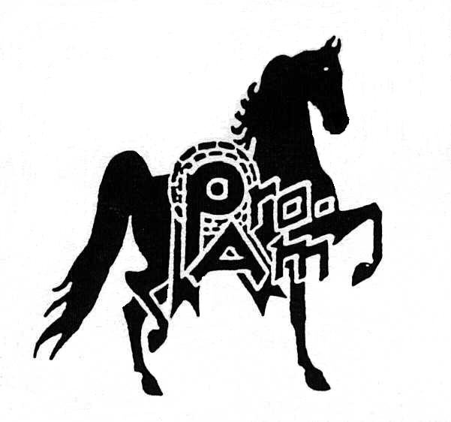
PRO AM BENEFIT CLASSIC HORSE SHOW
APRIL 3-6, 2019

JUDGE – GARY GARONE
MANAGER – SCOTT SNIDER
502 314 6025
bethandscott@kih.net
www.proamhorseshow.com

Wednesday 7pm
1. ASB Three Gaited Ladies
2. ASB Three Gaited Park Junior Horse
3. ASB Five Gaited Show Pleasure Adult
4. UPHA Pleasure Challenge Cup
5. ASB Three Gaited Junior Horse
6. ASB Five Gaited Ladies
7. Hackney Pony Open
8. Open Western Pleasure
9. ASB Fine Harness Open
10. ASB Three Gaited Park Amateur
11. ASB Three Gaited FL/GA O/T
12. HarnessPonyOpen
13. ASB Three Gaited Park Open
14. ASB Ladies Amateur Five Gaited
15. Roadster to Bike Open
16. ASB Five Gaited FL/GA O/T
17. Morgan Hunter Pleasure
18. ASB Three Gaited Open
19. RoadsterPonyOpen
20. ASB Five Gaited Open
Thursday 10am
21. Open Pleasure Driving
22. ASB Three Gaited Park Limit Horse
23. ASB Three Gaited Country Pleasure FL/GA O/T 24. HackneyPonyPleasureDriving
25. ASB Country Pleasure Driving
26. Open English Pleasure WT
27. HackneyPonyAmateur
28. Roadster Under Saddle
29. ASB Five Gaited Show Pleasure Limit Rider
30. Open English Pleasure WTC
31. TBD
32. Roadster Pony Limit
33. ASB Three Gaited Park Pleasure Junior Horse
34. HarnessPonyAmateur
35. MorganWesternPleasure
36. ASB Five Gaited Show Pleasure FL/GA O/T
37. ASB Show Pleasure Driving
38. ASB Hunter Country Pleasure
39. ASB Five Gaited Limit Horse
40. ASB Three Gaited Show Pleasure Fl/GA O/T
41. OpenPleasureVersatilityWestern/English

Thursday 7pm
42. Saddle Seat Equitation Walk/Trot 10 & Under
43. ASB Three Gaited Limit Horse
44. ASB Three Gaited Show Pleasure 13 & Under
45. Roadster Pony Amateur
46. ASB Three Gaited Country Pleasure Adult
47. ASB Three Gaited Show Pleasure 14-17
48. ASB Three Gaited Amateur
49. ASB Five Gaited Show Pleasure Junior Exhibitor 50. ASB Three Gaited Show Pleasure Adult
51. ASB Three Gaited Park Pleasure
52. Roadster to Bike Amateur
53. ASB Three Gaited Park Pleasure Amateur
54. ASB Three Gaited Junior Exhibitor
55. ASB Five Gaited Junior Horse
56. ASB Three Gaited Country Pleasure 14-17
57. ASB Fine Harness Amateur
58. ASB Three Gaited Park Junior Exhibitor
59. ASB Three Gaited Western Country Pleasure 60. ASB Five Gaited Junior Exhibitor
61. Roadster to Bike Limit
62. ASB Five Gaited Adult Amateur

Friday 10am
63. Saddle Seat Pleasure Walk/Trot 12 & Under
64. UPHA Roadster Pony Classic
65. Open Western Pleasure Stake
66. ASB Three Gaited Country Pleasure 13 & Under
67. Open Pleasure Driving Stake
68. ASB Three Gaited Show Pleasure Limit Rider
69. AHHS Roadster Pony Medallion
70. Saddle & Bridle Hunter Classic
71. ASB Three Gaited Park Pleasure Limit Horse
72. Country Pleasure Walk/Trot 12 & Under
73. ASB Five Gaited Country Pleasure
74. Open English Pleasure Walk/Trot Stake
75. AHHSHackneyPonyPleasureDrivingMedallion
76. ASB Three Gaited Country Pleasure Limit Rider
77. Saddle Seat Equitation 13 & Under
78. Saddle Seat Equitation Adult
79. Three Gaited Pony
80. Three Gaited Pleasure Pony
81. Five Gaited Pony
82. Five Gaited 3 Year Old
83. Saddle Seat Pleasure Equitation 17 & Under
84. Saddle & Bridle Working Western Pleasure

Friday 7pm
85. Good Hands Event
86. ASB Three Gaited Park Amateur Stake
87. Saddle Seat Equitation 14-17
88. Roadster Pony Adult Amateur Stake
89. Saddle & Bridle Wm. Shatner Western Pleasure
90. ASB Three Gaited Ladies Stake
91. Saddle & Bridle Pleasure Equitation Medallion
92. ASB Three Gaited Park 3 Year Old
93. ASB Five Gaited Show Pleasure Adult Stake
94. ASB Fine Harness Junior Horse
95. ASB Three Gaited Show Pleasure 13 & Under Stake 96. ASB Three Gaited Park Pleasure 3 Year Old
97. ASB Show Pleasure Driving Stake
98. Roadster to Wagon Stake
99. ASB Three Gaited Park Stake
100.ASB Country Pleasure Driving Stake
101.ASB Three Gaited 3 Year Old
102.ASB Three Gaited Show Pleasure 14-17 Stake 103.Hackney Pony Stake
104.Open English Pleasure Stake
105.ASB Five Gaited Ladies Stake

Saturday 10am
106.Country Pleasure Walk/Trot 12 & Under Stake 107.UPHA Exceptional Challenge Cup (without assistance) 108.Exceptional Showmanship
109.Saddle Seat Equitation Adult Championship 110.AHHS Roadster Pony Under Saddle Medallion 111.Five Gaited Pony Stake
112.Morgan Western Pleasure Stake
113.UPHA Challenge Cup
114.Three Gaited Pleasure Pony Stake
115.ASB Five Gaited Show Pleasure Limit Rider Stake 116.ASB Three Gaited Country Pleasure Limit Rider Stake 117. ASB Five Gaited Country Pleasure Stake
118.UPHA Walk/Trot Challenge Cup
119.ASB Hunter Country Pleasure Stake
120.Three Gaited Pony Stake
121.ASB Three Gaited Show Pleasure Limit Rider Stake 122.Morgan Hunter Pleasure Stake
123.Saddle Seat Walk/Trot Pleasure 12 & Under Stake 124.ASB Three Gaited Park Pleasure Amateur Stake 125.Senior Horse Class
126.UPHA Exceptional Challenge Cup (with assistance)
127.SESHA Medallion

Academy -30 minutes after class 127
128.Lead Line
129.Walk/Trot Showmanship Lead Line 8 & Under 130.Walk/Trot Equitation Lead Line 8 & Under 131.Showmanship Driving
132.Reinsmanship Driving
133.Showmanship WTC Adult
134.Equitation WTC Adult
135.Showmanship WTC 17 & Under
136.Equitation WTC 17 & Under
137.WTC Championship
138.Showmanship WT 14 & Over
139.Equitation WT 14 & Over
140.Showmanship WT 11-13
141.Equitation WT 11-13
142.Showmanship WT 9-10
143.Equitation WT 9-10
144.Showmanship WT 8 & Under
145.Equitation WT 8 & Under
146.Hunt Seat Showmanship WT
147.Hunt Seat Equitation WT
148.WT Championship

Saturday 7pm
149.Equitation Championship
150.Ladies Amateur Five Gaited Stake
151.Hackney Pony Pleasure Driving Championship 152.ASB Three Gaited Country Pleasure Adult Stake 153.ASB Three Gaited Park Jr. Exhibitor Stake 154.Roadster to Bike Amateur Stake
155.ASB Three Gaited Country Pleasure 13 & Under Stake 156.ASB Western Country Pleasure Stake
157.Harness Pony Stake
158.ASB Five Gaited Junior Exhibitor Stake
159.Roadster Pony Jr. Exhibitor Stake
160.ASB Fine Harness Stake
161.ASB Three Gaited Country Pleasure 14-17 Stake 162.ASB Three Gaited Show Pleasure Adult Stake 163.ASB Three Gaited Amateur Stake
164.Roadster Under Saddle Stake
165.ASB Five Gaited Show Pleasure Jr. Exhibitor Stake 166.ASB Three Gaited Stake
167.ASB Three Gaited Jr. Exhibitor Stake
168.Roadster Pony Stake
169.ASB Five Gaited Amateur Stake
170.ASB Three Gaited Park Pleasure Stake
171.Roadster to Bike Stake
172.Five Gaited Stake

